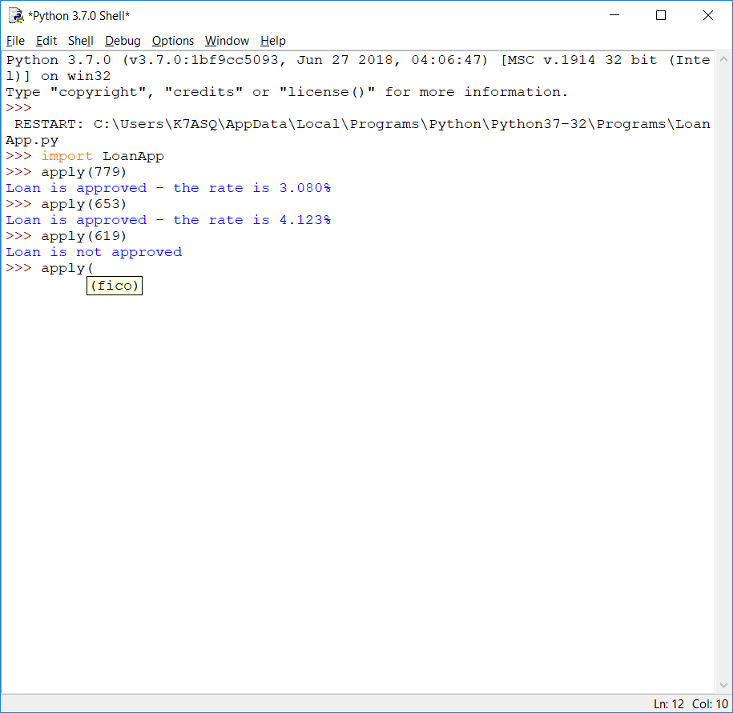

For this program, I was comfortable writing the code for the program from the pseudo-code provided, but getting the function to work correctly took a few tries. It wasn’t really covered in the reading, but there was a short video in Module 2 and combined with prior knowledge of how a function should work, I got it working. The biggest problem I ran into was trying to give the function itself the same name as the module. After I figured out that’s where my problem was, it was smooth sailing to complete the program. In this case, a function is useful because it allows information to be passed into the function for processing. For example, this function could be part of a larger banking program. The customer’s account would contain their current FICO score, which could then be passed into the function with a click of a mouse. Instead of prompting the banker to enter the FICO score, this data would be passed automatically and the results returned without further interaction from the user.